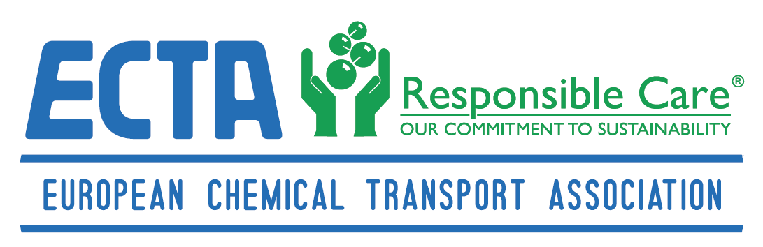

Project Charter

Electronic European Cleaning Document or e-ECD

10 March 2017

Electronic European Cleaning Document

Table of contents

I. Project Statement Summary 3
II. Project Overview 3
A. Problem statement 3
B. Project Approach 4
C. Overview of the e-ECD Project Stakeholders : Objective & Benefits 4
III. APPENDIX 6
A. Appendix 1: Terminology/Glossary 6

Project Statement Summary

The objective of this e-ECD project is to digitalize the current ECD paper document while sharing it “transactionally” using latest Cloud technologies and this to increase the overall operational efficiency, quality and safety among the members of EFTCO, essenscia-Cefic and ECTA.

While this sounds a straightforward objective, the complexity of an e-ECD collaborative cloud project is driven by the large number of players involved, the alignment of the business & system requirements, the different IT legacy systems already in use, the different operational processes and regulations and the required level of data security to build trust among all stakeholders. Related to the latter point of data security, one of the major barriers preventing stakeholders to enter in automated data exchange interactions concerns data confidentiality and unauthorized intrusion and usage of sensitive data. That in mind it is crucial that any ECD or any other related data which are stored and shared via this e-ECD application remain the sole property of the respective participating chemical, transport and cleaning companies in the way that they jointly agree upon. Further processing or use of these data in any way by the IT service provider is strictly prohibited.

Project Overview

Problem statement

For companies active in the chemical industry, tank cleaning is a cornerstone in the logistics
process for which safety, quality, operational efficiency and compliance needs to be safeguarded. In order to achieve this, a paper-only European Cleaning Document (ECD) has been launched in July 1st, 2005. This ECD has been developed by EFTCO in collaboration with ECTA and CEFIC, in order to satisfy the needs of the cleaning stations, transport companies and chemical, feed and food manufacturing companies and its customers.

Whilst this ECD was a giant leap forward, the current paper based process does not meet all current challenges and expectations anymore. At the same time, technological capabilities have evolved significantly over the past decade, allowing the stakeholders to address this gap.

Zooming into further details on the cleaning document itself , the rules to issue an ECD document can be found through the link:
http://www.eftco.org/european-cleaning-document/explanation-and-guidance
The content & required fields to issue an ECD document can be found through the link:
http://www.eftco.org/european-cleaning-document/specific-information
An example ECD can be consulted through:
http://www.eftco.org/european-cleaning-document/example-ecd

Project Approach

In terms of Project Approach the project is split in 2 phases :

- A PILOT -PHASE 1 project to demonstrate your digitalized e-ECD IT solution within a smaller process scope and with the full pilot development, configuration & solution built in 2017

- A PHASE 2 project that entails the further e-ECD solution roll out of PHASE 1 towards all European stakeholders in 2018 including the upgraded IT platform costs, the ‘on going’ IT support tools and organization and e-learning roll out tool in 18 EU languages. In addition to the geographical roll out in Europe, Phase 2 will also require new developments and system enhancements e.g. capturing unloading customer information, GPS tracking information of logistics assets, etc

A schematic overview is given in the picture below.

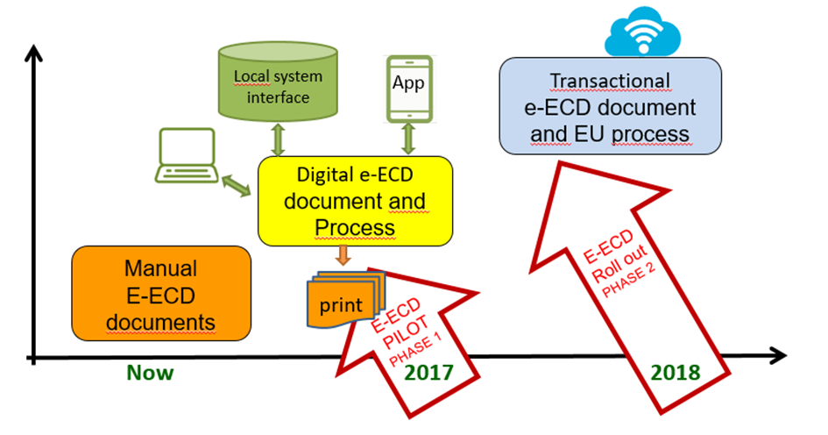
Picture 1: e-ECD project steps: Roll out of electronic ECD document and related process

Overview of the e-ECD Project Stakeholders : Objective & Benefits

The e-ECD project is being led by the ECTA association and this in close collaboration with EFTCO and ESSENSCIA federations whereof:
- ECTA stands for European Chemical Transport Association and represents over 100 transport company members. www.ecta.com
- EFTCO stands for the European Federation of Tank Cleaning Organizations www.eftco.org and represents close to 485 Tank cleaning companies
- ESSENSCIA is the Belgian Federation for Chemistry and Life Sciences www.essenscia.be and is a member of the European Chemical Industry council
Cefic www.cefic.org . Essenscia represents the chemical companies in Belgium.

All 3 Partners are supporting the digitalization of the ECD document and do share the common project objectives and benefits which can be summarized in 3 categories being:

- Quality & Compliance : accurate product information
The basis for a seamless collaboration between the chemical, transport and tank cleaning companies is to ensure that accurate & timely information is being exchanged throughout the tank cleaning, loading and customer delivery process. Converting the manual ECD document to a digitalized e-ECD form and related process will help to make this communication process between all parties less error prone, more transparent and real time which in turn helps to deliver a high quality product & service to the end Customer.

- Responsible Care & Safety
The aim for more safety and higher responsible care standards is a cornerstone within the strategy of each stakeholder. Misinformation due to non-transparency of product data, inconsistent safety data information or data delays, can cause dangerous situations for all stakeholders in their specific operations. Accurate product & cleaning information combined with the right skilled people and the appropriate technical installations are the essential elements to guarantee a safe & sustainable cleaning process.

- Operational excellence
Automating the capturing and digitalizing the exchange of ECD information could mean less manual work, faster site entrance & loadings, less rework & checks and reduced waiting times. Shortening the historical product blacklists leads to higher asset availability, which reduces costs and increases efficiency. Besides, increased accessibility of data and an elevated trust level in the e-ECD information is a precursor for a spot checks driven process where companies with a positive track record and complete information can be given access to fast lanes.

APPENDIX

Appendix 1: Terminology/Glossary

CEFIC “European Chemical Industry Council”

CMR Convention on the Contract for the International Carriage of Goods by Road

ECD “European Cleaning Document” – The ECD is a support document for
every single tank cleaning in the supply chain process. It is not a certificate
but proves which cleaning steps have been performed.

ECTA “European Chemical Transport Association”

EFTCO “European Federation of Tank Cleaning Organizations”

ESSENSCIA The Belgian Federation for Chemistry and Life Sciences industries

PMO Project Management Office. A PMO coordinates the overall project administration tasks together with all stakeholders and covers both the technology and functional project requirements. It organizes the project steering meetings.

PM Project Manager who is responsible to represent the project team and manage his specific knowledge part of the project.

SULID “Site (Un)loading Information Document” - An uniform site (un)loading
document (SULID) has been developed by a joint Cefic-ECTA-FETSA-FECC

